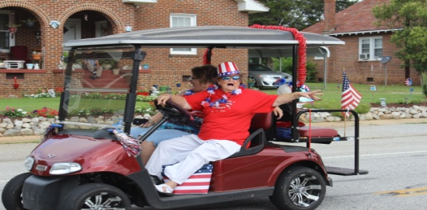
SC FESTIVAL OF STARS™ MAIN STREET PARADE Saturday July 2nd starting at 10 am-No Entry Fee
Parade Entrant Name:________________________________________
Contact Name:______________________________________________
Address:___________________________________________________
Phone:____________________________ Email:___________________
Please mark your parade entry category with an X
Commercial Business___ Church___ Wheeled ___ Individual ____ Group___
Please indicate the vehicle type, size and/or number in group for line-up
Float/length_________________ Car(s) __________________
Golf Cart____________________ Horses __________________
Motorcycle__________________ Walking ___________________
Brief Description _________________________________________________
Upon entry all participants recognize and acknowledge that neither the Town of Ninety Six, or the County of Greenwood are responsible for any injuries incurred as a result of participation in the parade, before, during or after the event. The parade is for fun and is free community event
FOR ADDITIONAL QUESTIONS PLEASE CALL 864-543-3396 or email Tourism96@nctv.com
Line-up starts at 9:00 am on MAIN Street by the 96 Train Depot
WWW.SCFESTIVALOFSTARS.COM facebook.com/scfestivalofstars Twitter- @scfestivalofstars

